Updated fuzz_run.sh for verification convenience, as described below:

1, Added Delete Files and Create Files

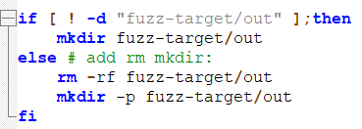

2, Modified a permissions issue that I encountered when first ran fuzz_run.sh

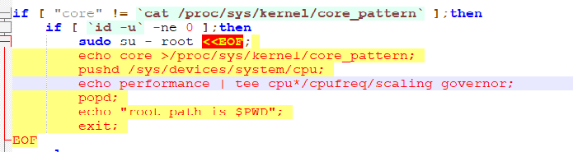

3, The comment indicates that there is a problem followed a description of the problem:

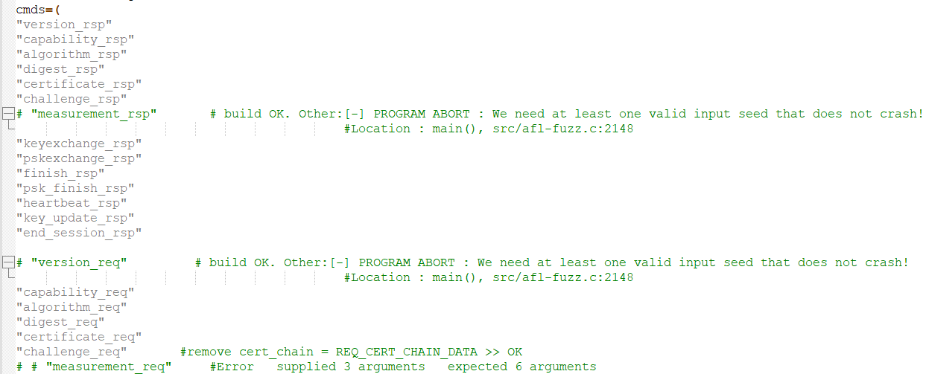

4, During the verification, the test method was modified, and it needs to be changed back later

